SQL Saturday Volunteer Instructions

**Registration Desk –** Youare the first face!

1. When the attendee/speaker arrives, check them in on the Eventbrite App by scanning their ticket or manually entering their information.
2. Give them a bag.
3. Tell them about the stamp game raffle.
4. Direct speakers to the speaker room.

**Room Proctor –** Help the speaker.

1. Introduce yourself to the speaker and make sure they are set up on the AV equipment.
2. Ask the speaker if they would like a 5-minute warning.
3. Get a headcount once people have stopped coming into the session. Text the room number and/or session title and the count to the number at the bottom of this page.
4. **LSU has a NO FOOD/DRINKS in the rooms in the classrooms policy. Politely remind folks if needed.**
5. Remind folks to fill out session evals online.
6. If you are the last session of the day, make sure that the room is clean and take any trash/left items to the kitchen.

**Speaker Room Monitor**

1. Make sure all speakers have the Wi-fi information.
2. Make sure that the room is stocked with water.

**Greeter/Info Dispenser (Everyone)**

1. Keep a map and schedule with you and answer any questions.

**Vendor Area Setup/Breakdown**

1. Direct the vendors to their designated tables as they arrive in the morning.
2. Ask if you can help them get set up.
3. At the end of the day, ask again if you can help them break down.
4. **THANK THEM FOR BEING HERE**
5. At the end of the day, we must put the dining tables back how they were and return the long vendor tables to storage.

**Lunch and Snacks**

1. Lunch should arrive by 11:30. Help stage the prepackaged meals in the dining room.
2. Pass out lunches as people come through the line.
   1. Vegetarian meals should be reserved for those that requested them.
   2. If there are extras after the lines have calmed down, then they can be given to anyone.
3. Once lunch is over, clean up the service and dining areas.
4. Keep an eye on the ice chests and make sure they are stocked throughout the day.

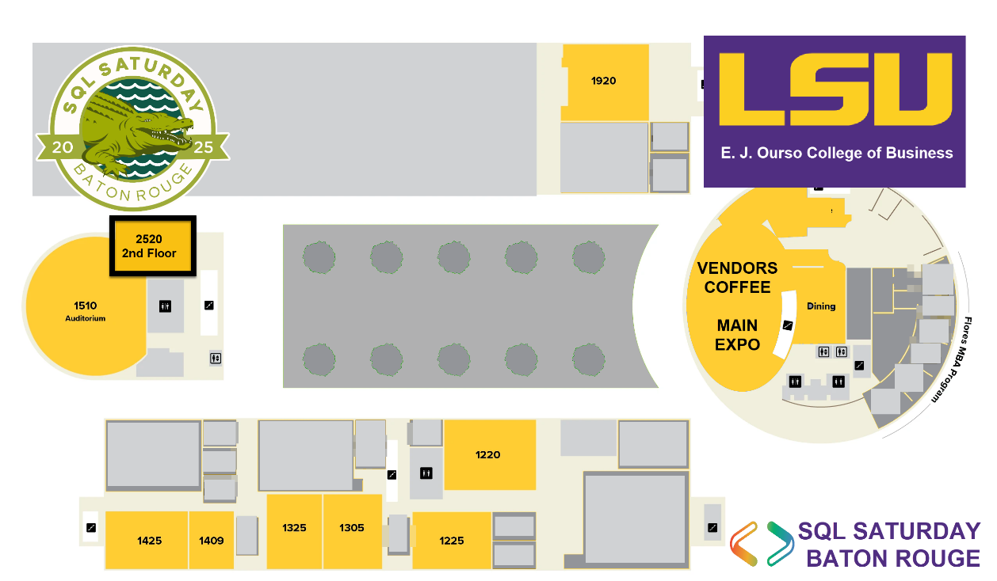Everyone should keep an eye out for spills and clean or report them immediately.   
Trash cans should be emptied as often as is necessary.

Everyone: Start directing people to the Auditorium for the closing raffle at 3:30.

If you need help, call or text   
(###) ###-####

**Guest Wi-Fi:**

1. Guest Username: Xxxxxx
2. Guest Password: xxxxxx